🎲 1. What Is Probability?
Probability measures how likely an event is to happen.
It’s a number between 0 and 1.
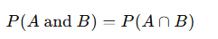
Example:
If you flip a coin:
- ( P(Head) = 0.5 )
- ( P(Tail) = 0.5 )
If you roll a die:
- ( P(\text{Getting 4}) = \frac{1}{6} )

🎯 2. Joint and Conditional Probability

(a) Joint Probability
The probability of two events happening together.
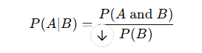
Example:
If 60% of people like coffee, and among those, 50% also like tea,
then ( P(\text{coffee and tea}) = 0.6 \times 0.5 = 0.3 ).

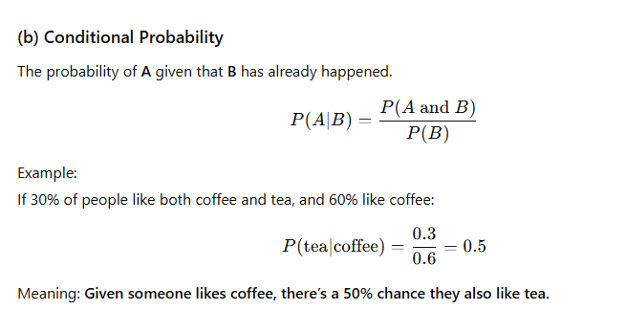
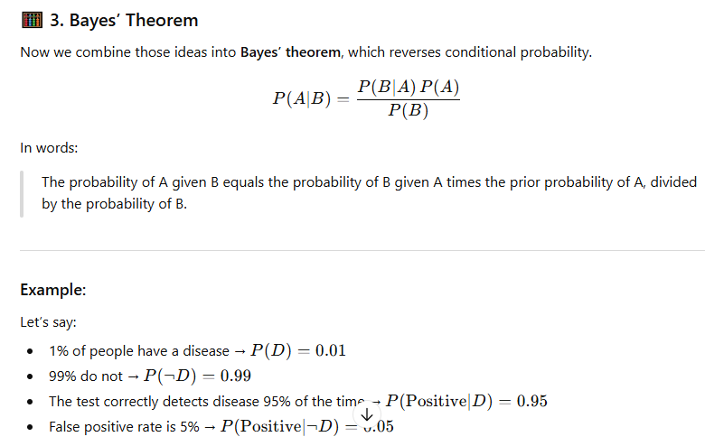

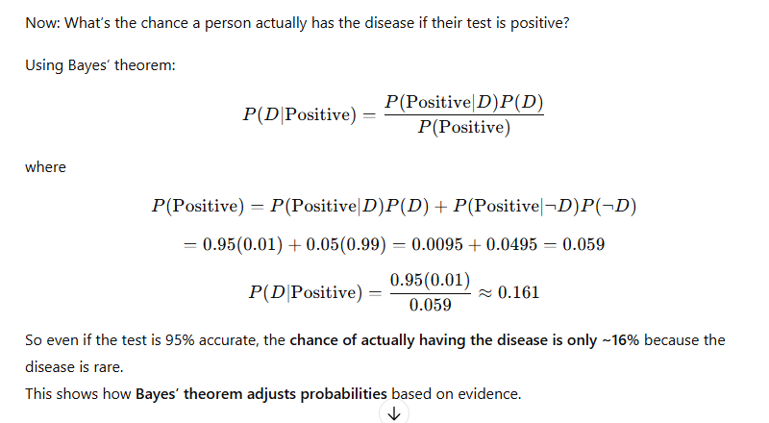

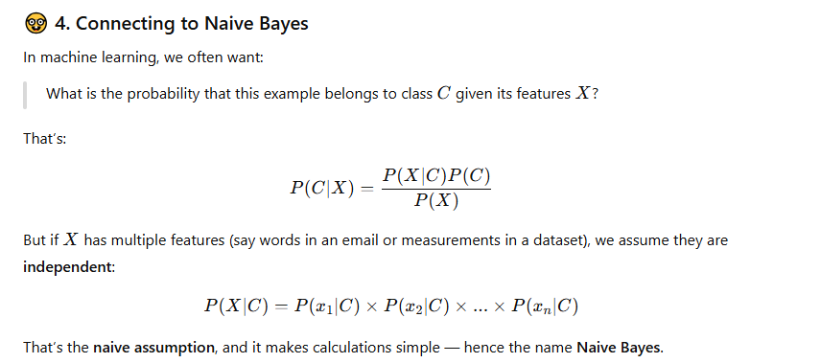

🤓 4. Connecting to Naive Bayes
In machine learning, we often want:
What is the probability that this example belongs to class ( C ) given its features ( X )?
That’s:
[
P(C|X) = \frac{P(X|C)P(C)}{P(X)}
]
But if ( X ) has multiple features (say words in an email or measurements in a dataset), we assume they are independent:
[
P(X|C) = P(x_1|C) \times P(x_2|C) \times ... \times P(x_n|C)
]
That’s the naive assumption, and it makes calculations simple — hence the name Naive Bayes.

If you’d like, next we can go over step 5: how to use these probabilities in an actual classification problem, e.g.:
Given some words in an email, predict if it’s spam or not.
Would you like to continue with that next

